**Penguin Interactive Unit Test**

1.Entering a Char instead of int: [PASS]

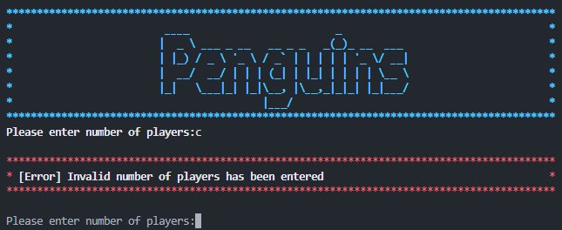

It throws an error as expected and it requests the player to Enter the number of the players again.

2.Entering an unrealistic number of players: [PASS]

If the number of the players entered is less than 2, which in this case makes it unrealistic the program will throw an error and request a correct number.

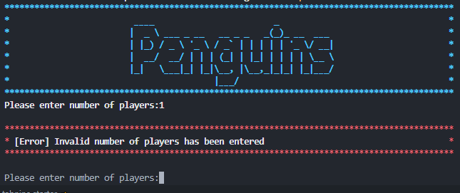

3.Entering an unrealistic coordination on the board: [PASS]

If the coordination entered by the player are out of the bounds of the board, which in this case makes it unrealistic the program will throw an error and request a correct number.

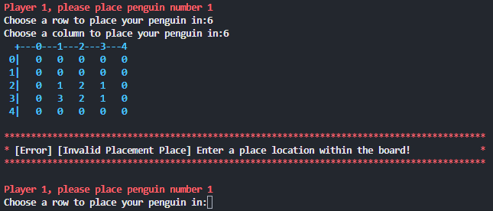

4.Checking obstacles: [PASS]

If the player tried to do an illegal move the program should throw an error and it requests the player to re enter a new coordination.

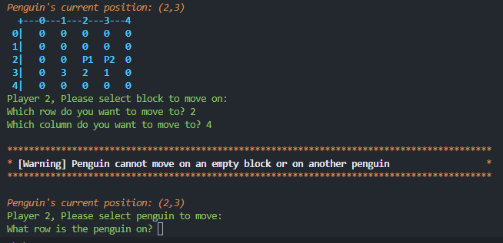

4.Movement: [PASS]

Check if the Player can only move in straight line and If the player to move diagonally the program will throw an error.

